# Practical No: 6

## Hadoop Installation:

**Date: 17/04/2023**

### **Aim:** Install, configure e4tr `and run Hadoop and HDFS and explore HDFS on Windows

**Steps:**

#### Steps to Install Hadoop

1. Install Java JDK 1.8
2. Download Hadoop and extract and place under C drive
3. Set Path in Environment Variables
4. Config files under Hadoop directory
5. Create folder datanode and namenode under data directory
6. Edit HDFS and YARN files
7. Set Java Home environment in Hadoop environment
8. Setup Complete. Test by executing start-all.cmd

#### There are two ways to install Hadoop, i.e.

1. Single node
2. Multi node

Here, we use multi node cluster.

#### Install Java

* + – Java JDK Link to download

o <https://www.oracle.com/java/technologies/javase-jdk8-downloads.html>

* + – extract and install Java in C:\Java
  + – open cmd and type -> javac -version

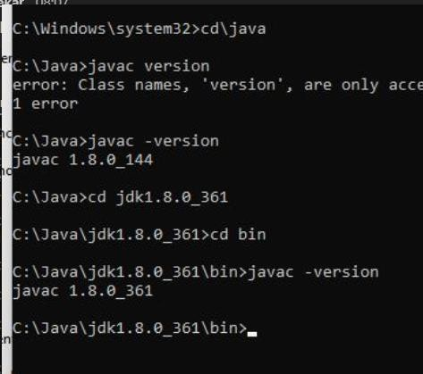

#### Download Hadoop

<https://www.apache.org/dyn/closer.cgi/hadoop/common/hadoop-3.3.0/hadoop-3.3.0.tar.gz>

* + right click .rar.gz file -> show more options -> 7-zip->and extract to C:\Hadoop-3.3.0\

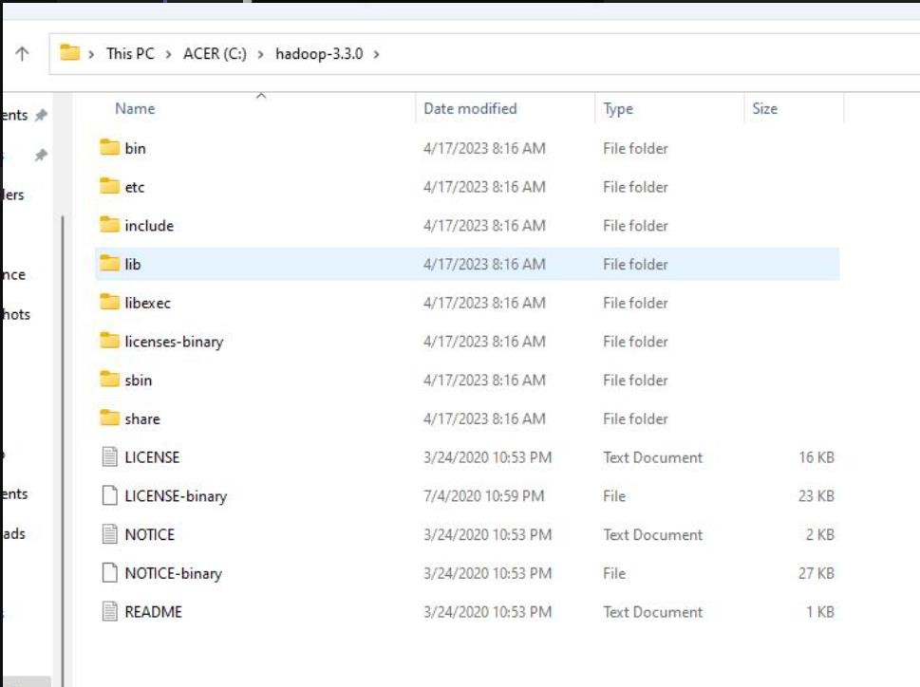

#### Set the path JAVA_HOME Environment variable

1. **Set the path HADOOP_HOME Environment variable Click on New to both user variables and system variables.**

**Click on user variable -> path -> edit-> add path for Hadoop and java upto ‘bin’**

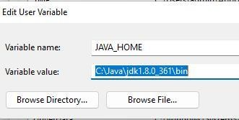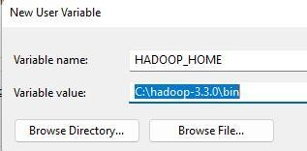

Click Ok, Ok, Ok.

#### Configurations

**Edit file C:/Hadoop-3.3.0/etc/hadoop/core-site.xml,**

paste the xml code in folder and save

<configuration>

<property>

<name>fs.defaultFS</name>

<value>hdfs://localhost:9000</value>

</property>

</configuration>

## ======================================================

#### Rename “mapred-site.xml.template” to “mapred-site.xml” and edit this file C:/Hadoop- 3.3.0/etc/hadoop/mapred-site.xml, paste xml code and save this file.

**======================================================**

<configuration>

<property>

<name>mapreduce.framework.name</name>

<value>yarn</value>

</property>

</configuration>

## ======================================================

#### Create folder “data” under “C:\Hadoop-3.3.0”

**Create folder “datanode” under “C:\Hadoop-3.3.0\data” Create folder “namenode” under “C:\Hadoop-3.3.0\data”**

**======================================================**

**Edit file C:\Hadoop-3.3.0/etc/hadoop/hdfs-site.xml, paste xml code and save this file.**

<configuration>

<property>

<name>dfs.replication</name>

<value>1</value>

</property>

<property>

<name>dfs.namenode.name.dir</name>

<value>/hadoop-3.3.0/data/namenode</value>

</property>

<property>

<name>dfs.datanode.data.dir</name>

<value>/hadoop-3.3.0/data/datanode</value>

</property>

</configuration>

## ======================================================

#### Edit file C:/Hadoop-3.3.0/etc/hadoop/yarn-site.xml, paste xml code and save this file.

<configuration>

<property>

<name>yarn.nodemanager.aux-services</name>

<value>mapreduce_shuffle</value>

</property>

<property>

<name>yarn.nodemanager.auxservices.mapreduce.shuffle.class</name>

<value>org.apache.hadoop.mapred.ShuffleHandler</value>

</property>

<property>

</property>

<property>

<name>yarn.resourcemanager.address</name>

<value>127.0.0.1:8032</value>

<name>yarn.resourcemanager.scheduler.address</name>

<value>127.0.0.1:8030</value>

</property>

<property>

</property>

<name>yarn.resourcemanager.resource-tracker.address</name>

<value>127.0.0.1:8031</value>

</configuration>

## ======================================================

1. **Edit file C:/Hadoop-3.3.0/etc/hadoop/hadoop-env.cmd**

Find “JAVA_HOME=%JAVA_HOME%” and replace it as set JAVA_HOME="C:\Java\jdk1.8.0_361"

## ======================================================

#### Download “redistributable” package Download and run VC_redist.x64.exe

1. **Hadoop Configurations**

**Download bin folder from** [**https://github.com/s911415/apache-hadoop-3.1.0-winutils**](https://github.com/s911415/apache-hadoop-3.1.0-winutils)

## Copy the bin folder to c:\hadoop-3.3.0. Replace the existing bin folder.

1. **copy "hadoop-yarn-server-timelineservice-3.0.3.jar" from ~\hadoop- 3.0.3\share\hadoop\yarn\timelineservice to ~\hadoop-3.0.3\share\hadoop\yarn folder.**

#### Format the NameNode

* **Open cmd ‘Run as Administrator’ and type command “hdfs namenode –format”**

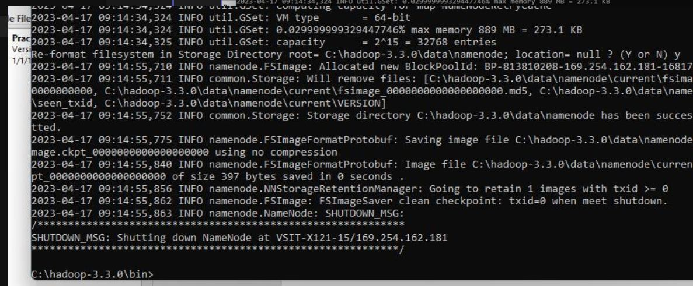

1. **Testing**

* Open cmd ‘Run as Administrator’ and change directory to C:\Hadoop-3.3.0\sbin
* type start-all.cmd OR

- type start-dfs.cmd

* type start-yarn.cmd

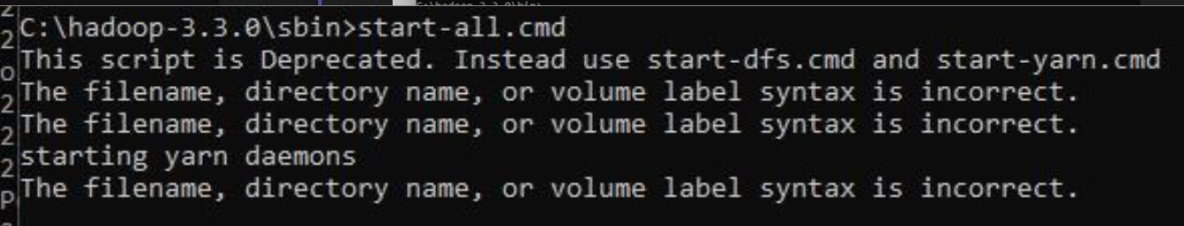

* You will get 4 more running threads for Datanode, namenode, resouce manager and node manager

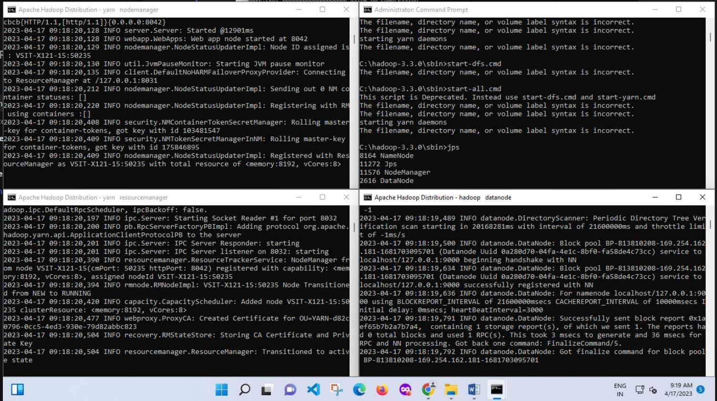

#### Output:

1. Type JPS command to start-all.cmd command prompt, you will get following output.

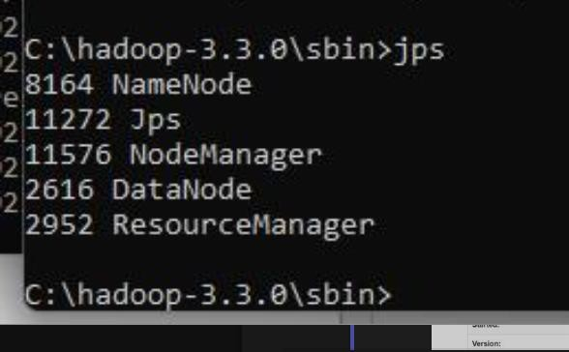

1. Run http://localhost:9870/ from any browser

